3/21/21

Sean Mayers

Week 2 | Create Groceries App

Ionic info: after many hours of troubleshooting the ionic installed without errors.

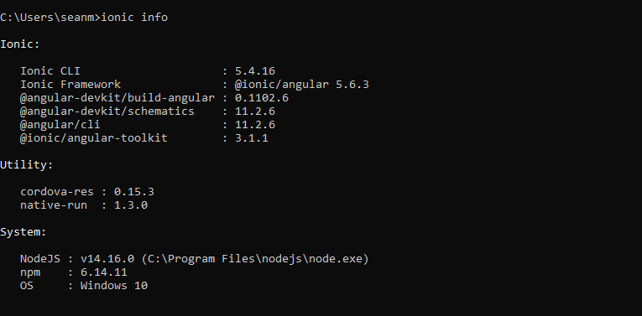

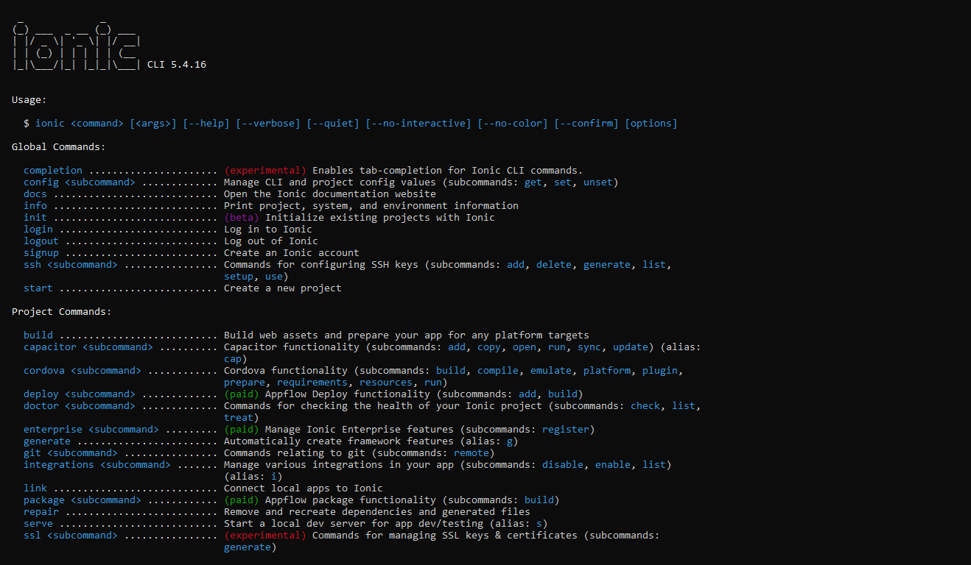

Also, these are the tabs included as opposed to Home, About and Contact. I will update the chats tab with my full name and Student ID.

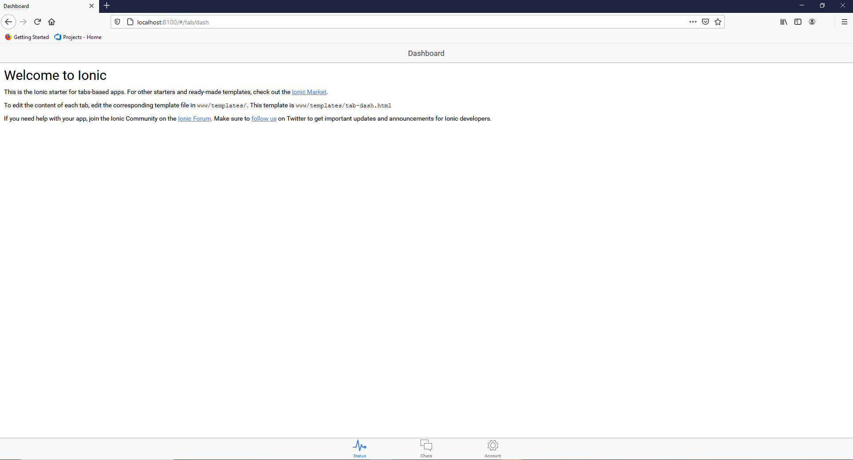

See update to chats tab below with my full name and Student ID.

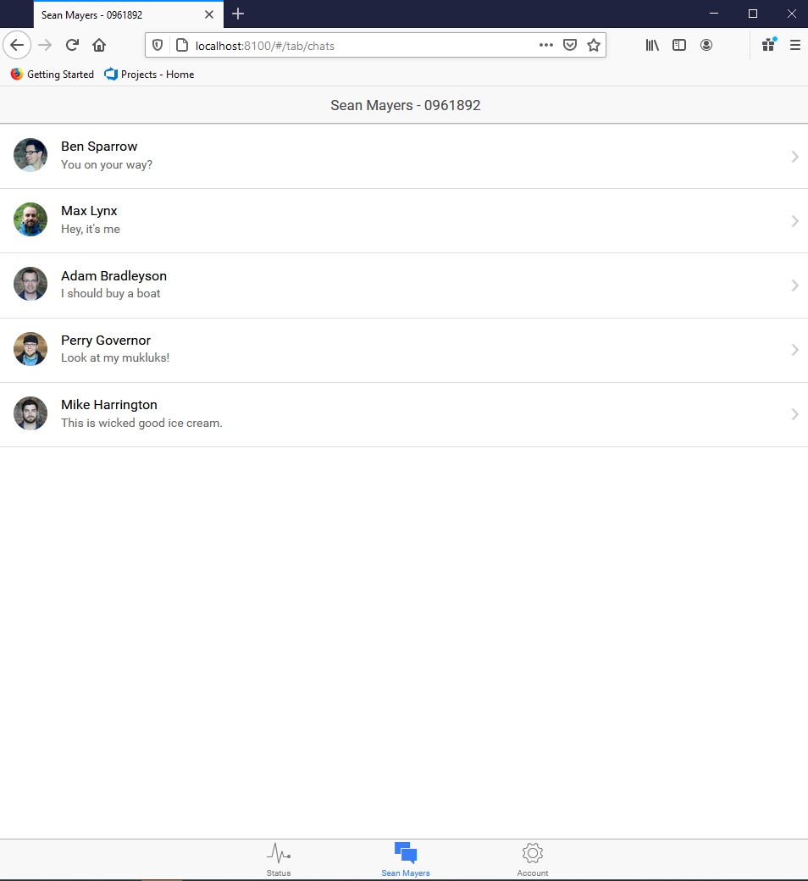

Grocery items added to list under home tab.

